
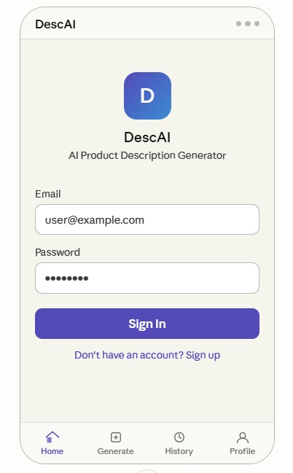

5. System Deployment & Integration
5.1 Technology Stack
This section identifies the software layers used to build, train, and serve the fashion description system.
Layer | Technology | Purpose
Language | Python 3.12 | Core programming language for data processing and AI.
UI Framework | Streamlit | Used to build the interactive web dashboard for fashion analysis.
AI Model | GPT-2 Medium | The foundational Large Language Model (LLM) for generating descriptions.
AI Libraries | Hugging Face Transformers, PEFT (LoRA) | For model loading, inference, and memory-efficient fine-tuning.
Data Processing | Pandas, NumPy | Handling datasets, feature engineering, and preprocessing.
Environment | Visual Studio Code | Managing dependencies and ensuring environment reproducibility.

5.2 Deployment Diagram
Since there is no specialized hardware, the deployment follows a Client-Server architecture. The "Server" can be a local machine or a cloud platform “Streamlit Cloud”
- Client Side (User Device): Accesses the system via a standard Web Browser (Chrome, Firefox, etc.).
- Server Side (Execution Environment): Python Runtime: Executes the generate.py and prompt_builder.py logic.
  - Model Storage: Holds the GPT-2 Medium weights and the fine-tuned LoRA adapters.
  - Streamlit Engine: Manages the real-time interaction between the user and the backend model.
5.3 Component Diagram
This diagram maps your actual folder structure (src/) to the logical modules of the system and shows how they depend on one another.
- Data Management Module (src/data/):
  - Responsible for loading raw fashion data and performing feature engineering.
  - Output: Cleaned datasets ready for training or inference context.
- NLP & Logic Module (src/nlp/):
  - Contains the prompt_builder.py which formats user inputs into templates that GPT-2 understands.
- Training Module (src/training/):
  - Handles the fine-tuning process via train_lora.py. This is an offline component used to optimize the model before deployment.
- Inference & UI Module (src/inference/ & Streamlit):
  - The "Heart" of the live system. It takes processed inputs from the NLP module, runs them through the model via generate.py, and displays the resulting fashion descriptions on the Streamlit interface.

